**Medical Laboratory Sciences**

**Graduation Project**

**Title:**

Data collection and data analysis of hematological results from Al Bukayriyah general hospital

**Prepared by:**

Faris Abdulhakim Ahmad

161110206

**Supervisor:**

Dr. Ahmad Mahmoud Ahmad Hassaneen

**Date:**

18 April 2021

**Abstract**

Medical data is important to help physicians in making medical decision and to help hospital management in making medical policy in the hospital. The example of medical decision that can be improved such as drug prescription, surgery decision and blood transfusion. While medical policy like facilities such as room for the in-department patients, the equipment for the hospital laboratory and blood bag for the blood bank. Hematology department is one crucial department in the hospital. It provides various important tests in hematology field such as complete blood count and coagulation test. With complete blood count as the main focus in this research. From the data we can provide better suggestion in medical decision and medical policy. And the purpose of this research is to have a clear picture of patients’ demographic data related to hematology of adult patients in Al Bukayriyah general hospital for the benefit of medical decision and policy.

**Keywords:** Hematology demographic data, medical decision, medical policy

**Introduction**

Vayena (2018) states, “Health-related data should be secure, accountable and transparent. The control of access data needs to cover not only data protection, but also the distribution of any benefits of the exploitation of personal data. Medical data has a lot of potential benefits but also risk of exploitation that needs to be addressed.”

In a research, the case-based approach to decision making yielded more accurate recommendations. This approach yielded 81.6% of correct recommendation in diagnostic and treatment compared to 40.31% of total correct recommendation using a single-layer neural network (Malykh, 2018).

Another paper said the policy that is made based on evidence data provides more effective healthcare for better health outcomes (Vassiliou, 2020).

Data transparency can be beneficial for public health as a journal states that data transparency from patients can help the government to promote public health, patient safety and research (Wang, 2019). Based on this statement, the government can tailor a specific policy according to the data from the population. For an example, if there is a high number of iron deficiency anemia case in the population, the government can promote iron rich diet and subsidize the iron supplements or foods high in iron so the population can have better diet and minimize the risk of iron deficiency anemia. Another example is when there is a high need in blood transfusion, the government can promote blood donation campaign and for further encouragement, the government can pay for each bag of blood donated by the donator.

CBC result can be the indicator of various diseases such as anemia, leukemia and bleeding disorder (Kawthalkar, 2020). And this CBC result will determine the medical decision of the hospital whether the physicians should perform blood transfusion to the patient or just prescribe supplement. The result also benefits the hospital managements in taking medical policy such as providing more blood supply in the blood bank when the trend of the blood transfusion increases or just provide more supplement for anemic patient in less severe case.

Another journal states that the data collected from patients can help human resource management in health care and help to personalize patient care (Sousa. 2019). The human resource can determine whether to hire more laboratory scientist for the hospital laboratory due to high workload or reducing the laboratory staff for better efficiency. And for personalized patient care, this action can help physician to make the best decision for particular patient, best in health outcome and budget.

The personalized medical decision is further explained by a journal that this personalization yielded 86% of confirmed correctness level of the proposed medical decisions. These kinds of decisions make it possible to predict the optimal general state for a particular person, which will help to improve satisfaction and ensure patient longevity (Melnykova, 2020).

A study states that Saudi Arabia has a high number of iron deficiency anemia case. With 4 regions are included in that study: Dammam, Makkah, Madina and Riyadh (Owaidah, 2020). This study encourages us to do a similar research in Al Bukayriyah general hospital to confirm whether the iron deficiency anemia prevalence is high or low in Al Bukayriyah city.

A similar study is conducted in Riyadh showed that 41.6% of female samples have iron deficiency anemia (Alswailem, 2018). Thus, we want to compare these studies to our data to have better understanding of demographic data of Al Bukayriyah general hospital patients and provide good suggestions.

**Material and Methods**

Hematology analyzer XT-2000i is used in Al Bukayriyah general hospital. The machine is based on fluorescence flow cytometry technique and connected to a computer to display the data which it is derived from.

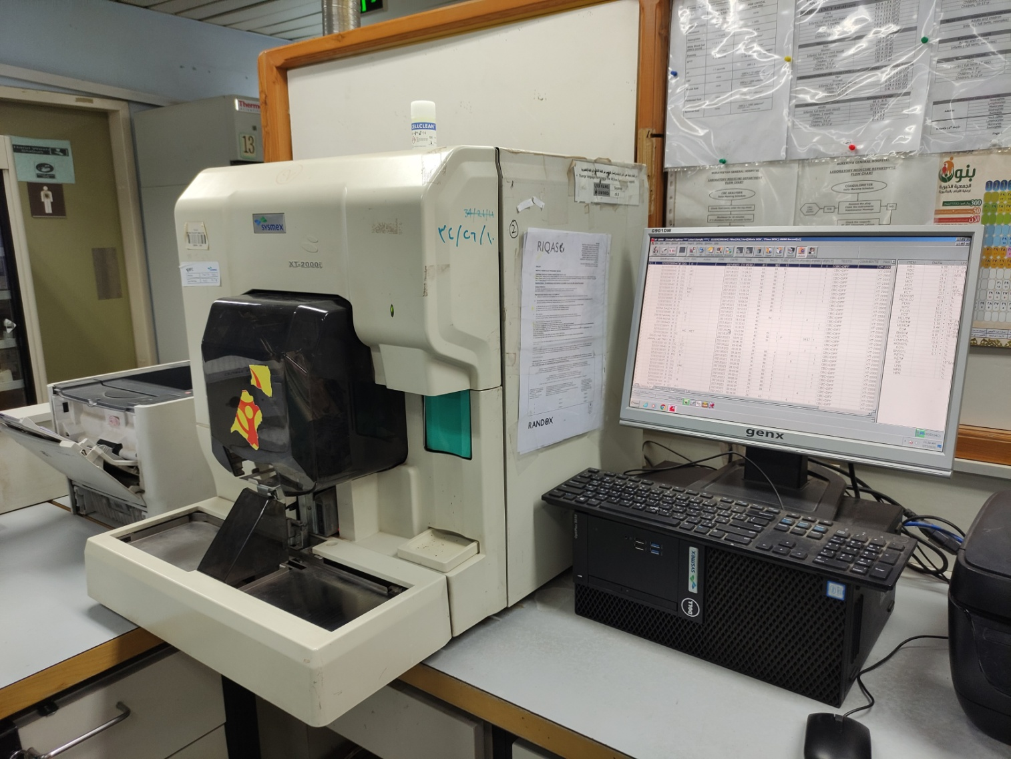

Hematology analyzer XT-2000i

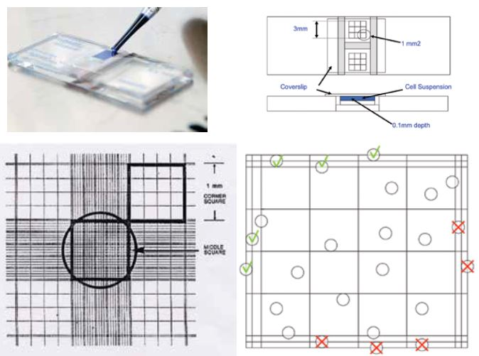

Hemocytometer

The fluorescence flow cytometryis the technique that is being used by most of the modern hematology analyzer today. While in the past the laboratory scientists were using hemocytometer to count the blood cells. The hemocytometer consists of a slide contains 9 bigger grids and many smaller grids inside each bigger grid. The blood is diluted in 1:200 dilution in a saline solution for RBC analysis and 1:20 dilution in glacial acetic acid for WBC analysis. The stain used is Trypan blue stain.

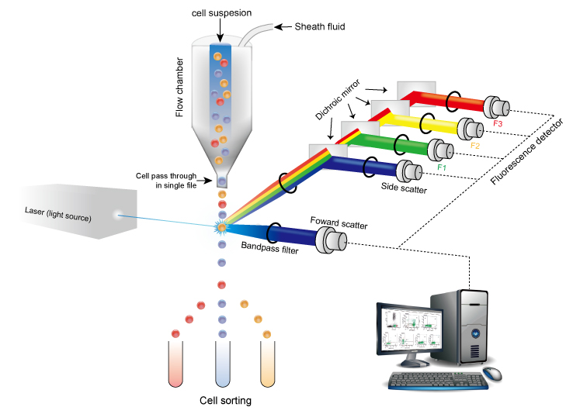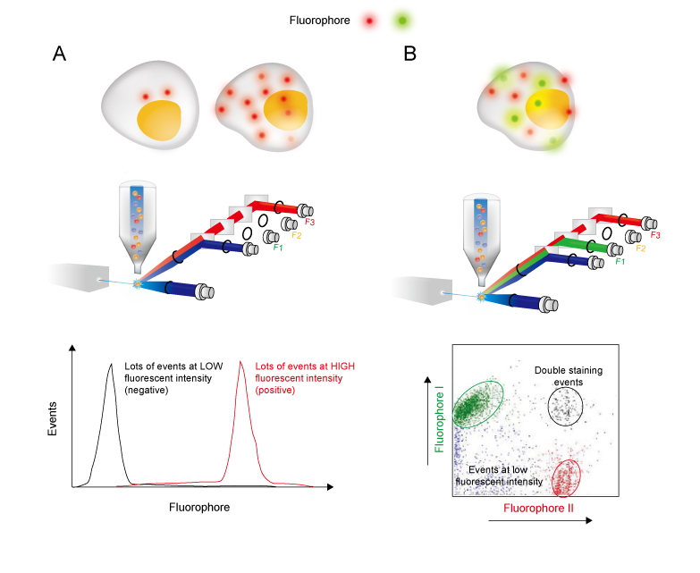

Fluorescence flow cytometry technique.

In the Fluorescence flow cytometry technique, the blood flows in single file in a flow chamber and it is passed by a laser light source. Once a single cell is passed by the laser, 2 scattered lights will be formed, forward-scattered light and side-scattered light. Forward-scattered light determines the size of the cell, the smaller cells like RBCs will have less forward-scattered light. While side-scattered light determines the granularity and complexity of the cell. Cells like granulocytes will have more side-scattered light due to their high granularity and complexity. And for further detection of similar cell the machine is accompanied by Fluorescence-labeled antibody to mark the surface marker of similar cells such as granulocytes. With this antibody the machine will be able to differentiate between neutrophils, eosinophils and basophils.

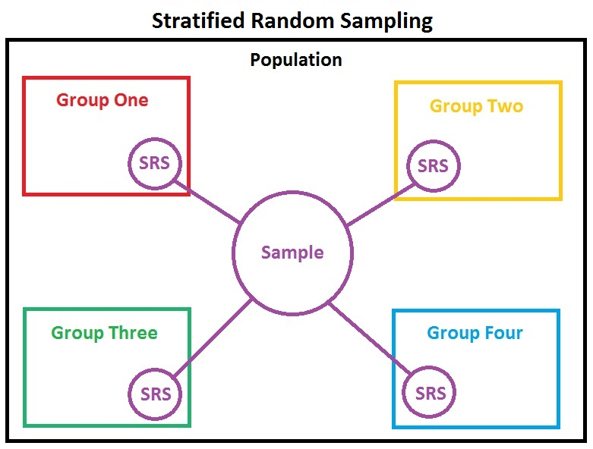

Stratified random sample sampling method is used to take the data from the hospital laboratory. 4 strata are defined by 4 days starting from 20th March 2021 to 23rd March 2021. And a total of 100 data was taken from the hospital which 25 patients’ data was taken randomly from each stratum.

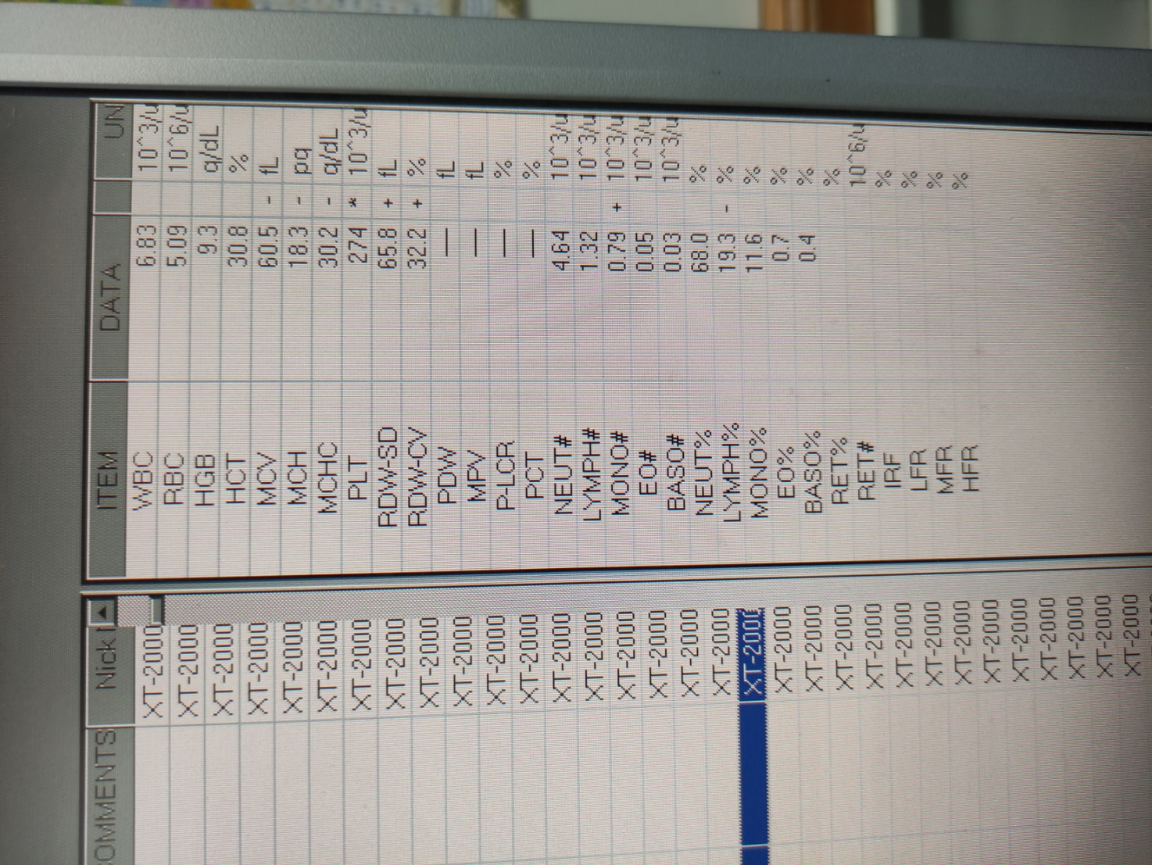

Example of a data taken

The most important parameters of CBC result are:

1. WBC
2. RBC
3. HGB
4. HCT
5. MCV, MCH and MCHC
6. PLT

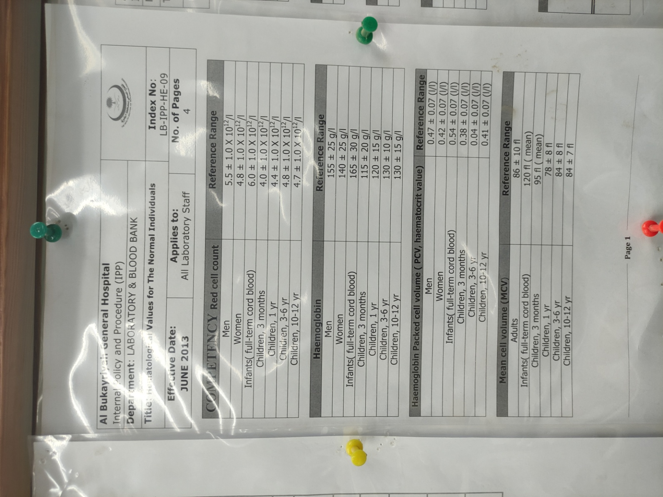 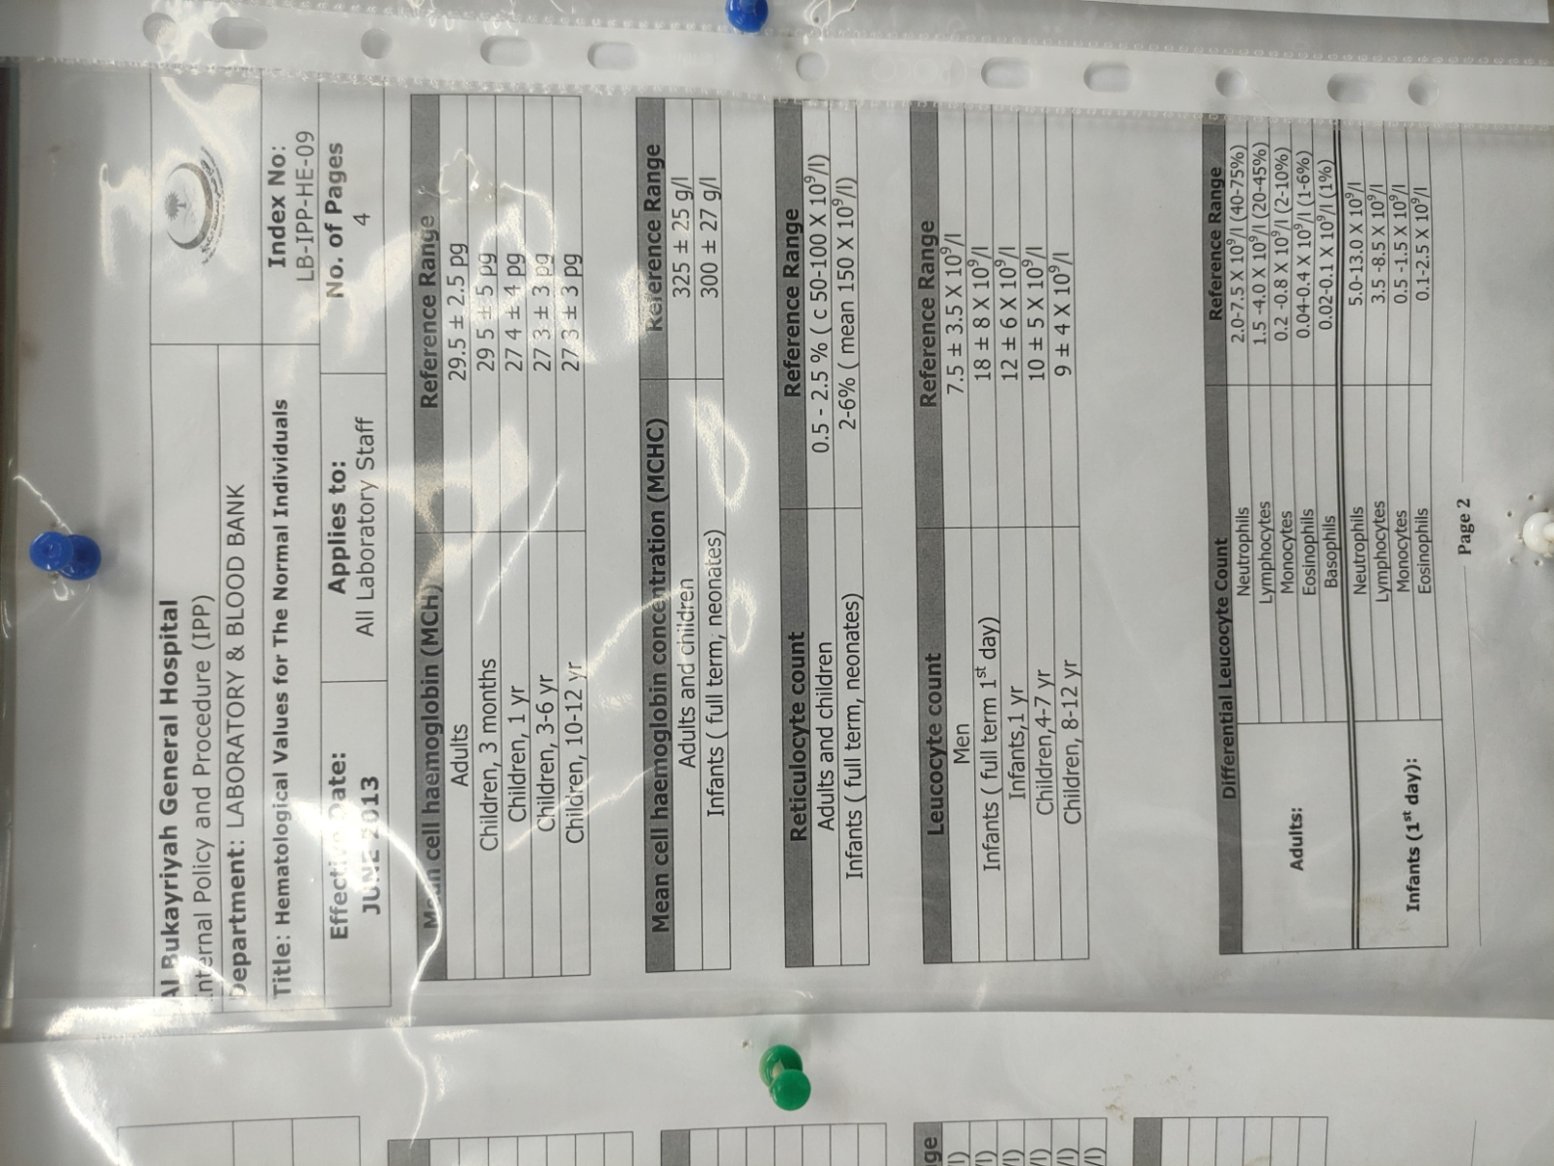 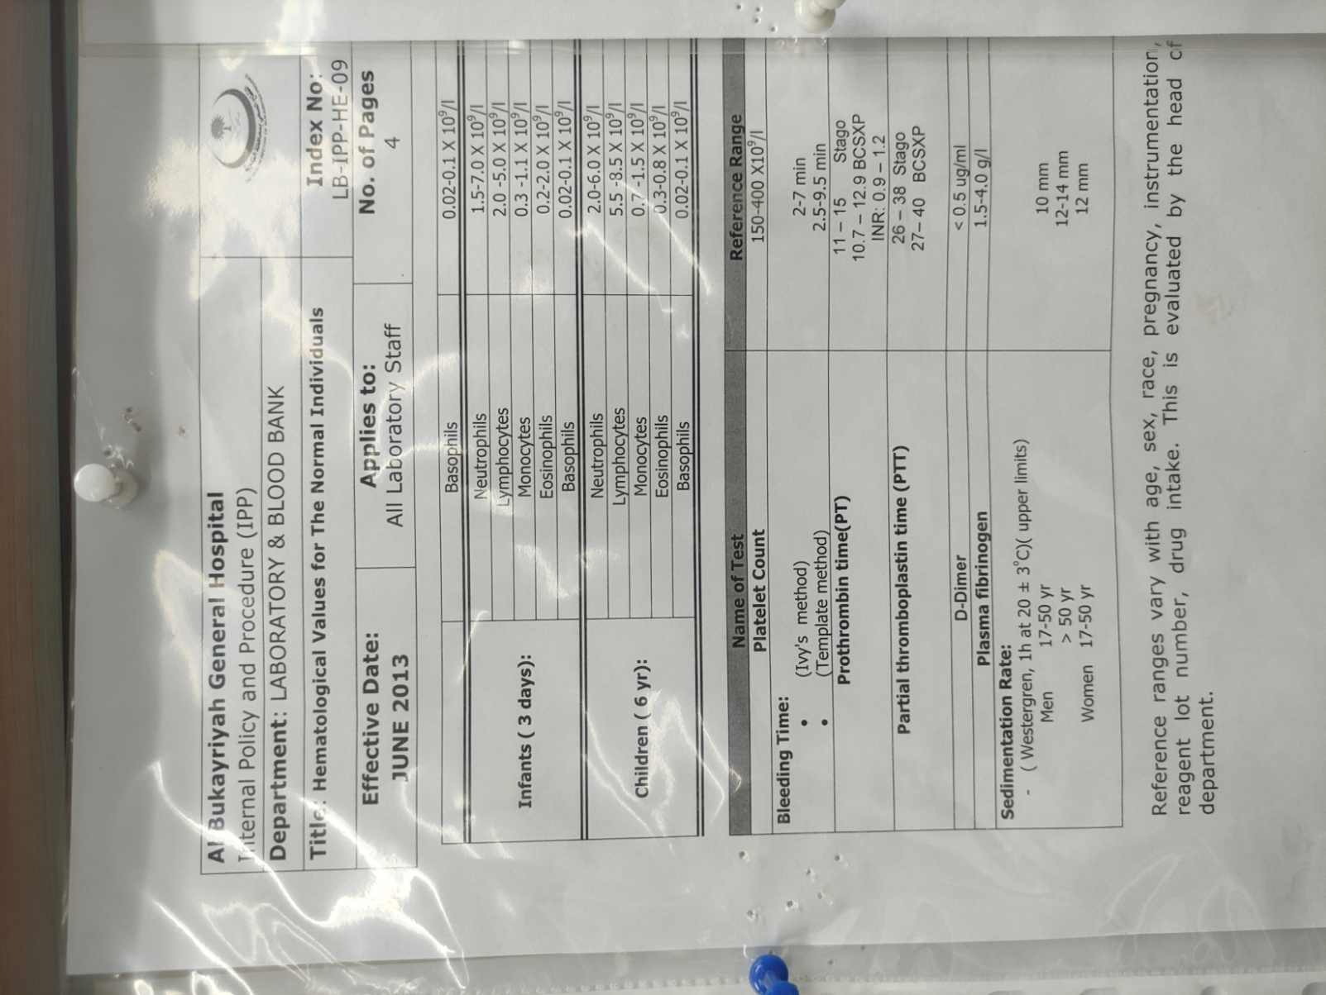 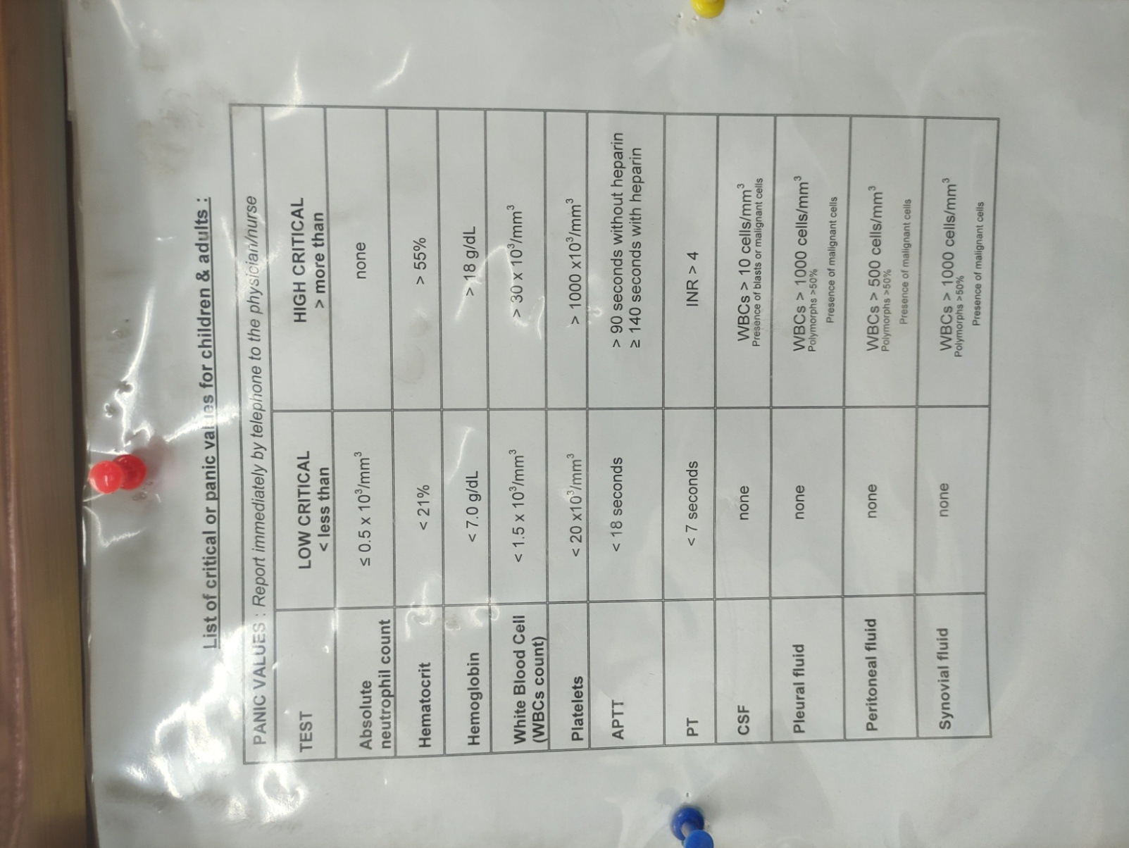

The reference ranges used in Al Bukayriyah general hospital

**Results and Discussion**

**Fig. 1**

As showed in (Fig. 1), majority of the patient at 88% have normal CBC result. 10% of them have non-critical abnormal value and the minority at only just 2% have critical value.



**Fig. 2**

Based on the overview data from (Fig. 2). Majority of the abnormality came from PLT abnormality with 5 patients PLT-independent abnormality and 1 patient with PLT and WBC abnormalities.

**Fig. 3**

**Fig. 4**



**Fig. 5**

(Fig. 3, 4 and 5) illustrate abnormality from each parameter. Majority of PLT abnormality came from low abnormal result at 67% according to (Fig. 3). While leukopenia made up the minority in WBC abnormality at 20% of the total WBC abnormality in (Fig. 4). For HGB abnormality, all of them have low MCV, MCH and MCHC with addition to low HCT in low critical HGB based on (Fig. 5).

**Fig. 6**

(Fig. 6) showed that All of HGB and HCT abnormality are accompanied by other abnormalities while majority of PLT abnormality is independent abnormality. In the other hand co-abnormalities are made up the majority of WBC abnormality.

According to our data, all patients with high PLT count have normal Platelet Distribution Width (PDW). This PDW is an indicator for reactive thrombocytosis (RT) as Kawthalkar (2020) states, “PDW is a measure of degree of variation of platelet size present in a blood sample. High PDW is seen in myeloproliferative disorders due to the presence of marked variation in size of platelets (giant to small). In secondary or reactive thrombocytosis, PDW is normal. Thus, PDW is an important value in differentiating essential thrombocythemia from secondary or reactive thrombocytosis.” Thus, these all normal PDW results indicate all the patients with high PLT count have RT.

Rokkam (2021) states, “Secondary thrombocytosis, also known as reactive thrombocytosis (RT) defined as an abnormally high platelet count due to underlying events, disease, or the use of certain medications. RT is the more common type and is usually identified in routine laboratory results. Among individuals with thrombocytosis, 80% to 90% are known to have RT.” The higher number is observed at Al Bukayriyah general hospital with 100% of all thrombocytosis are RT.

Kitchens (2019) explains, “In general, RT is a much more common cause of elevated platelet counts than ET or thrombocythemia due to the other MPNs. Reactive thrombocytosis (RT) is a common epiphenomenon of inflammatory (e.g., rheumatoid arthritis, inflammatory bowel disease) and neoplastic disease states, iron deficiency, and acute blood loss. In one study of 280 patients with extreme thrombocytosis (platelet count of ≥1,000,000/μL), 82% were found to have secondary causes of thrombocytosis, and only 14% had MPNs that produced elevated platelet counts.” While in Al Bukayriyah general hospital from all the patients that have high PLT count, all of them are caused by RT and none of them caused by primary thrombocytosis.

From the data taken, all the critical value patients have low HGB 7.0 and 6.2 g/dL respectively. Both have low MCV, MCH and MCHC. These parameters indicate microcytic hypochromic anemia as explained in a book (Kawthalkar, 2020). Both also have high Red cell Distribution Width (RDW-CV). Kawthalkar (2020) also states, “RDW is an indicator to distinguish iron deficiency anemia from β thalassemia minor (low MCV with high RDW: iron deficiency anemia; low MCV with normal RDW: β thalassemia minor).” Thus, all the critical patients are having iron deficiency anemia.

A study confirmed a high prevalence of iron deficiency anemia (IDA) with low HGB in 4 regions in Saudi Arabia: Dammam, Makkah, Madina and Riyadh. With the result of 11.5%, 9.8%, 10.2% and 10.9% respectively (Owaidah, 2020). In comparison with the data from Al Bukayriyah general hospital at only 2%.

Another study conducted by Alswailem (2018) states, “683 females of Saudi nationality were enrolled in Riyadh Unit of Hematology - Department of Internal Medicine consented to participate in this research. Their ages ranged between 18 and 40 years, with a mode age between 31-40 years. The study population’s overall prevalence of IDA was found to be 41.6%.” This number is remarkably higher compared to our data from Al Bukayriyah general hospital which the prevalence of IDA is only 2%.

**Conclusion**

With the majority of patients have reactive thrombocytosis and based on Rokkam (2021) statement, “Secondary thrombocytosis (reactive thrombocytosis) is a laboratory anomaly that resolves when the underlying causative condition is addressed. In most cases, the symptoms are due to an underlying disorder and not the thrombocytosis itself”. We can provide suggestions:

1. Physicians should address the cause of reactive thrombocytosis and perform further examination if the condition persists.
2. Hospital management should provide enough facility for further examination.

And for all the critical patients, the main problem of iron deficiency anemia is the diet. As Alswailem (2018) points out, “Our results have indicated that most of the females in the study sample were anemic and reported inadequate intakes of citrus, along with a lower level of consumption of red meat and fish.” We can suggest that:

1. Physicians should prescribe iron-rich diet and add iron supplement if needed.
2. Hospital management should provide enough iron supplement stock, advertise iron-rich diet and introduce iron-rich menu in hospital cafeteria.

**References**

1. Kawthalkar, SM. (2020) Essentials of Hematology. 3rd ed. New Delhi: Jaypee Brothers Medical Publishers.
2. Malykh VL, Rudetskiy SV. (2018) ‘Approaches to Medical Decision-Making Based on Big Clinical Data’. Hindawi, 2018, 10
3. Sousa MJ, Pesqueira AM, Lemos C, Sousa M, Rocha Á. (2019) ‘Decision-Making based on Big Data Analytics for People Management in Healthcare Organizations’. Journal of Medical System, 43, 290.
4. Melnykova N, Shakhovska N, Gregus M, Melnykov V, Zakharchuk M, Vovk O. (2020) ‘Data-Driven Analytics for Personalized Medical Decision Making’. Mathematics, 8, 1211.
5. Vogt-Schiavo K, Wolverton SE. (2021) Comprehensive Dermatologic Drug Therapy (Fourth Edition). 4th ed. Amsterdam: Elsevier.
6. Schwartz JS. (2017) Clinical and Translational Science (Second Edition). 2nd ed. Cambridge: Academic Press.
7. Müller H, Ünay D. (2018) ‘Medical Decision Support Using Increasingly Large Multimodal Data Sets‘. Big Data Analytics for Large-Scale Multimedia Search, 1, 14.
8. Dagliati A, Tibollo V, Sacchi L, Malovini A, Limongelli I, Gabetta M, Napolitan C, Mazzanti A, Cata PD, Chiovato L, Priori S, Bellazzi R. (2018) ‘Big Data as a Driver for Clinical Decision Support Systems: A Learning Health Systems Perspective’. *Front Digit Humanit*, 5, 8.
9. Capobianco E. (2019) ‘Data-driven clinical decision processes: it’s time’. *J Transl Med,* 17, 44.
10. Pickering BW, Gajic O, Ahmed A, Herasevich V, Keegan MT. (2013) ‘Data utilization for medical decision making at the time of patient admission to ICU’. Crit Care Med, 41(6), 1502-10.
11. Brdarić D, Samardžić S, Huskić IM, Dritsakis G, Sessa J, Śliwińska-Kowalska M, Pawlaczyk-Łuszczyńska M, Basdekis I, Spanoudakis G. (2020) ‘A Data-informed Public Health Policy-Makers Platform’. International Journal of Environmental Research and Public Health*,* 17(9), 3271.
12. Vassiliou AG, Georgakopoulou C, Papageorgiou A, Georgakopoulos S, Goulas S, Paschalis T, Paterakis P, Gallos P, Kyriazis D, Plagianakos V. (2020) ‘Health in All Policy Making Utilizing Big Data’. *Acta Inform Med*, 28(1), 65-70.
13. Wang Z. (2019) ‘Data integration of electronic medical record under administrative decentralization of medical insurance and healthcare in China: a case study’. *Isr J Health Policy Res,* 8(1), 24.
14. Vayena E, Dzenowagis J, Brownstein JS, Sheikh A. (2018) ‘Policy implications of big data in the health sector’. Bull World Health Organ, 96(1), 66-68.
15. Alaskar A, Rehan H, Mendoza MA, Alsahan A, Immanuel A, Alhejazi A, Abuelgasim K, Salama H, Damlaj M, Gmati G, Alzahrani M, Rather M, Alahmari B, Mugairi AA, Ahmed A. (2019) ‘Hematological Profile in the Saudi Population: Reference Intervals By Gender, Age and Regions’. *Blood,* 134, 5804.
16. Wang MC, Huang CE, Lin MH, Yang YH, Lu CH, Chen PT, Wu YY, Tsou HY, Hsu CC, Chen CC. (2018) ‘Impacts of demographic and laboratory parameters on key hematological indices in an adult population of southern Taiwan: A cohort study’. PLOS ONE, 13(8), 0201708.
17. Siraj N, Issac J, Anwar M, Mehari Y, Russom S, Kahsay S, Frezghi H. (2018) ‘Establishment of hematological reference intervals for healthy adults in Asmara’. BMC Res Notes, 11(1), 55.
18. Bain B, Bates I, Laffan M. (2017) Dacie and Lewis Practical Haematology. 12th ed. Philadelphia: Elsevier.
19. Hoffman R, Benz EJ, Silberstein LE, Heslop HE, Weitz JI, Anastasi J, Salama ME, Abutalib SA. (2018) Hematology Basic Principles and Practice. 7th ed. Philadelphia: Elsevier.
20. Rodak B, Carr J. (2016) Clinical Hematology Atlas. 5th ed. Philadelphia: Elsevier.
21. Rokkam VR, Kotagiri R. (2020) Secondary Thrombocytosis. In: StatPearls [Internet]. Treasure Island (FL): StatPearls Publishing.
22. Kitchens CS, Kessler CM, Konkle BA, Streiff, MB, Garcia DA. (2019) Consultative hemostasis and thrombosis. Philadelphia, PA: Elsevier.
23. Owaidah T, Al-Numair N, Al-Suliman A, Zolaly M, Hasanato R, Zahrani FA, Albalawi M, Bashawri L, Siddiqui K, Alalaf F, Almomen A, Sajid MR. (2020) ‘Iron Deficiency and Iron Deficiency Anemia Are Common Epidemiological Conditions in Saudi Arabia: Report of the National Epidemiological Survey’. Anemia, 2020, 8.
24. Alswailem A, Alahmad S, Alshehri M. (2018). ‘The Prevalence of Iron Deficiency Anemia and its Associated Risk Factors among a Sample of Females in Riyadh, Saudi Arabia’. The Egyptian Journal of Hospital Medicine, 72(6), 4625-29.